GITHUB,DOCKER and JENKINS Integration

Tasks to be performed:

1. Create a container image that’s has Jenkins installed using Dockerfile. When we launch this image, it should automatically start the Jenkins service in the container.
2. Create a job chain of job1, job2, job3 and job4 using build pipeline plugin in Jenkins
3. **Job1:** Pull the Github repo automatically when some developers push the repo to Github.
4. **Job2:** By looking at the code or program file, Jenkins should automatically start the respective language interpreter install image container to deploy code. Here my code is of HTML, hence Jenkins should start the container that has HTML already installed.
5. **Job3:** Test your app if it is working or not.
6. **Job4:** if the app is not working, then send an email to the developer with error messages.
7. **Job5:** Create One extra job not belonging to the pipeline to monitor: If the container where the app is running. fails due to any reason then this job should automatically start the container again.

1.Creating a container Image:

write the below codefor creating a docker image containing Jenkins, in a file called Dockerfile,which can be kept inside a folder so that we can launch the Docker image

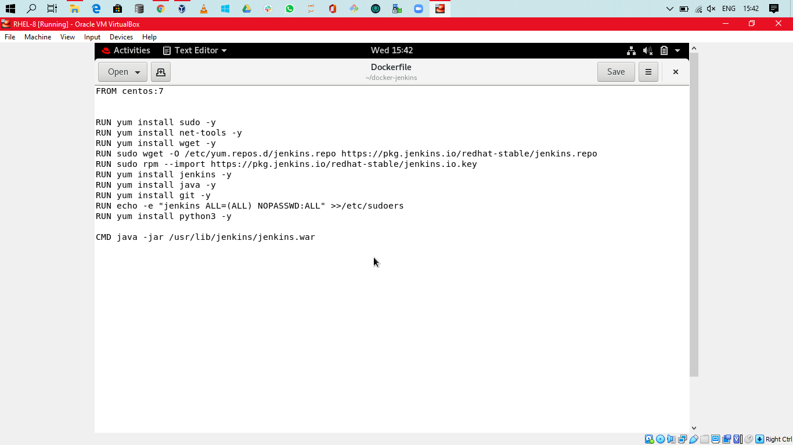

2. Job1 in Jenkins to pull repo automatically from GitHub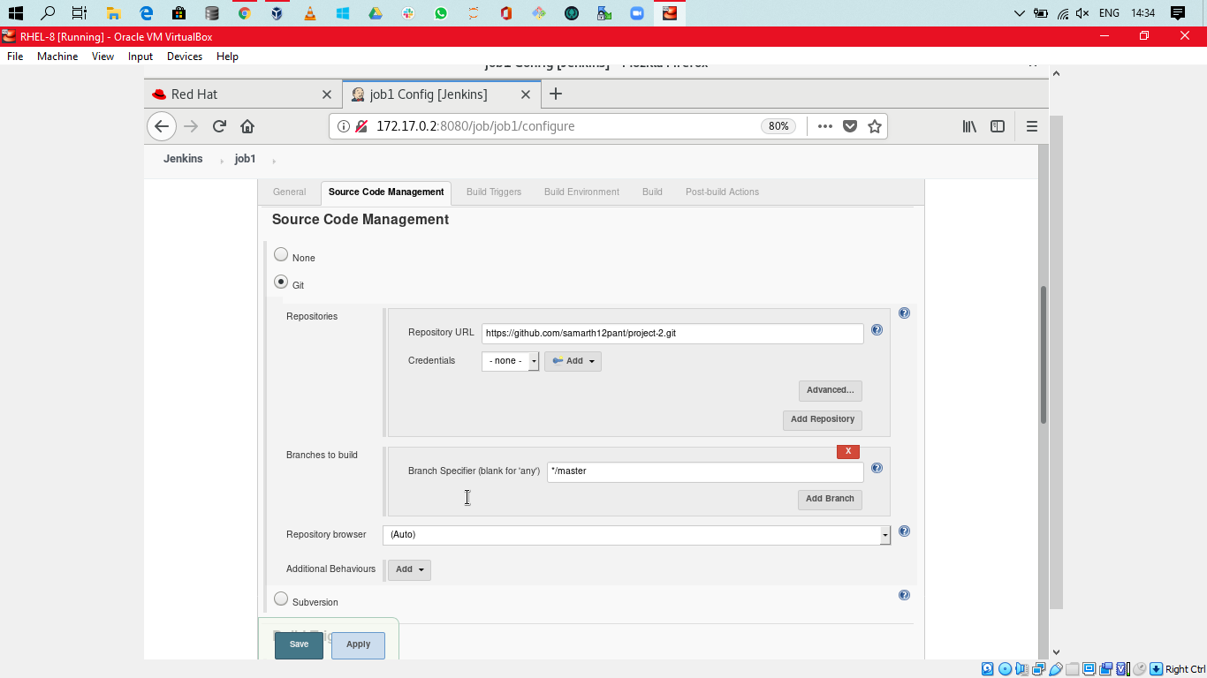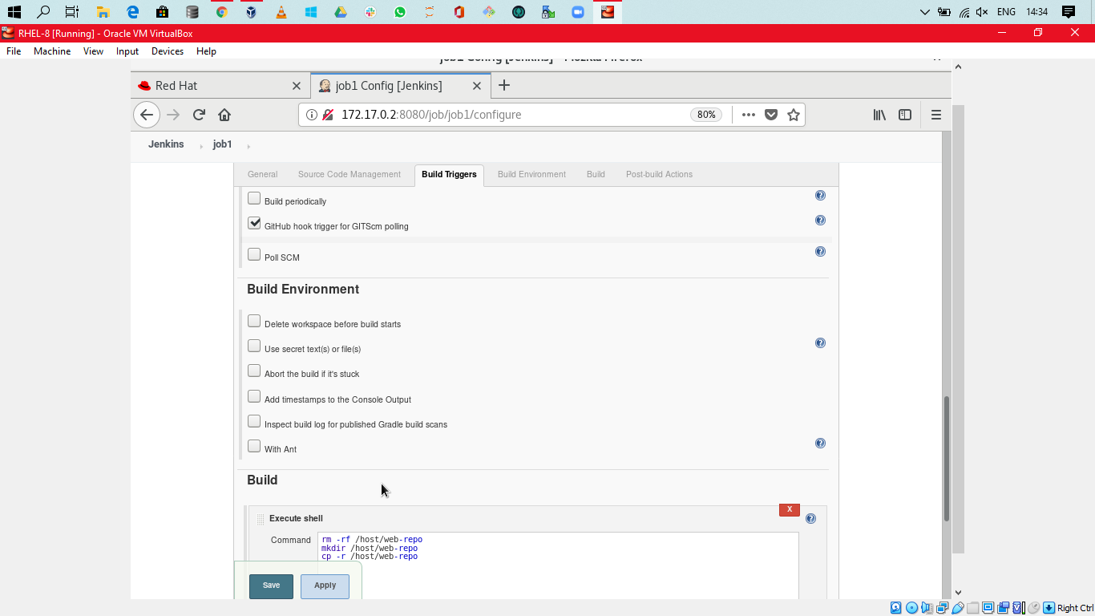

3.Job2 in Jenkins to start httpd server(as doc is html type):

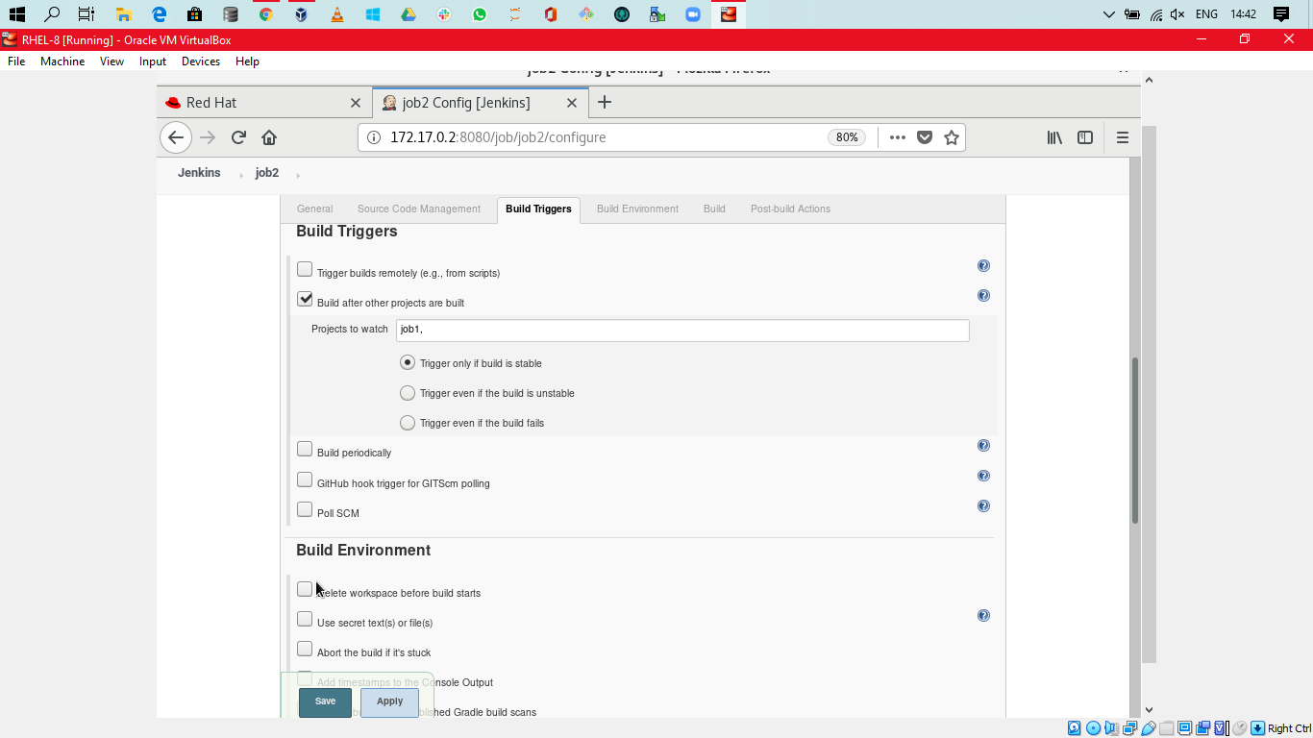

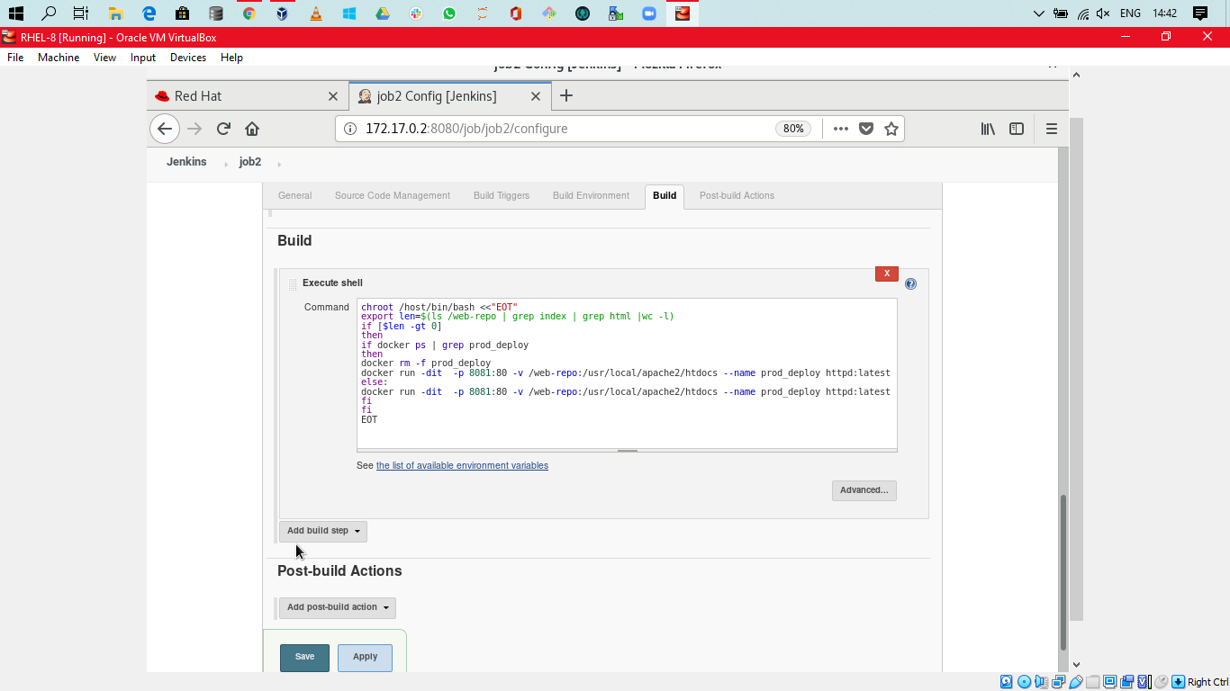

4.Job 3 for testing the APP:

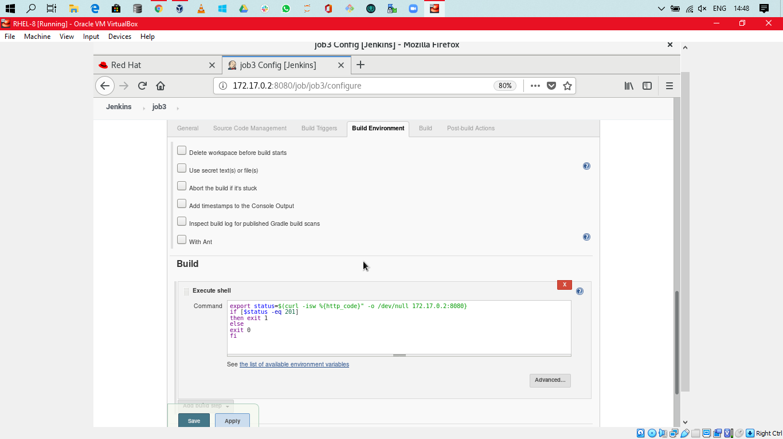

5. Job 4 for email notification(used python script to send mail to developer):

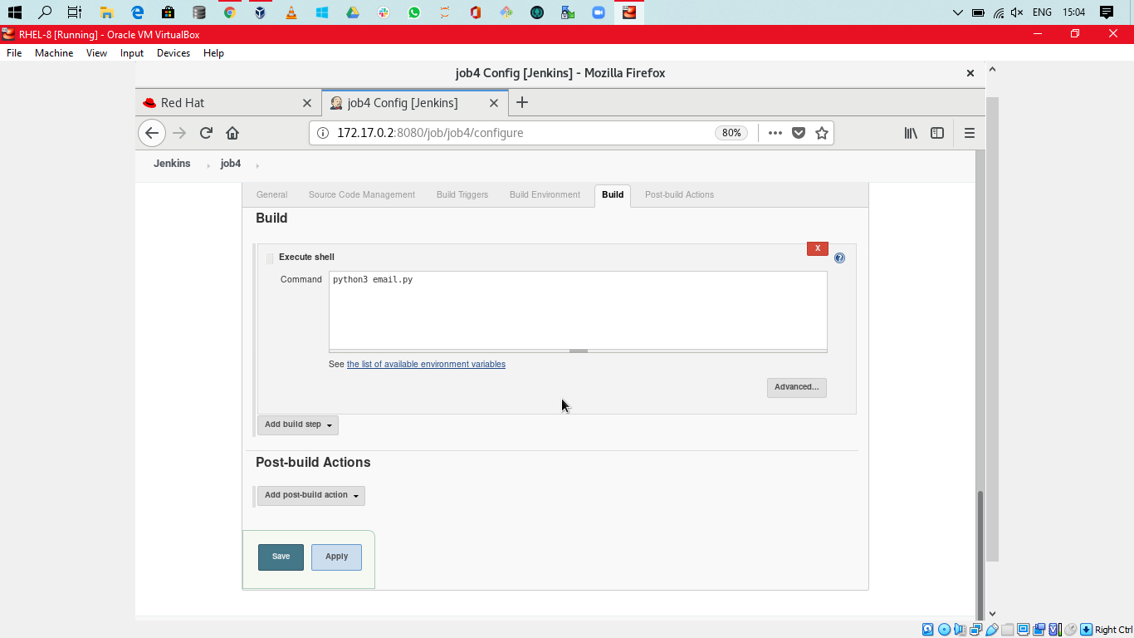

6.Job 5 which automatically starts container if itcontainer fails due to any reason:

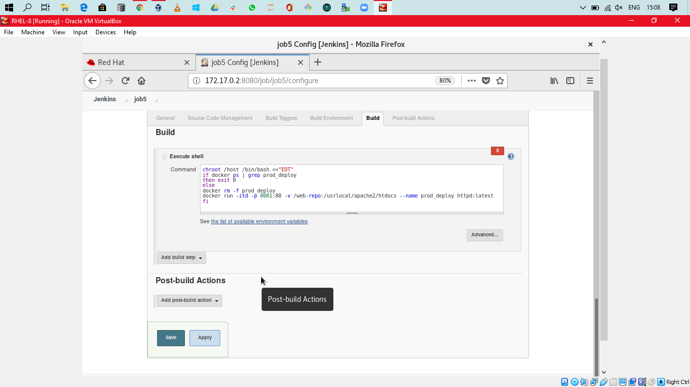

Behind the scene:

Email script:

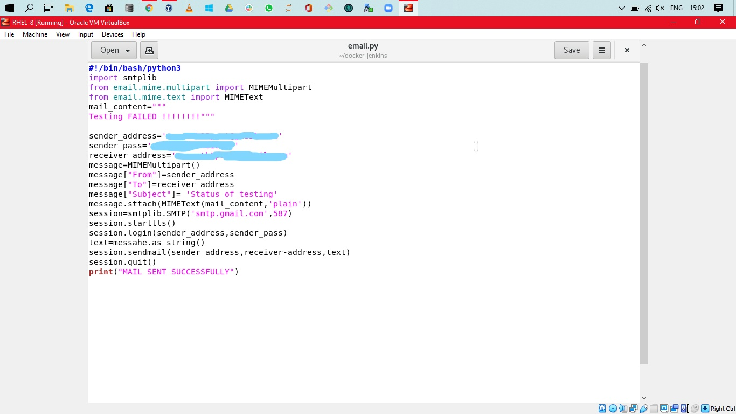

Launching of docker image:

